Exercise – 09

**/src/components/IndianPlayers.js**

import React from 'react';

const IndianPlayers = () => {

  const allPlayers = ['Sachin1', 'Dhoni2', 'Virat3', 'Rohit4', 'Yuvaraj5', 'Raina6'];

  // Destructuring using indexes

  const [first, second, third, fourth, fifth, sixth] = allPlayers;

  const oddPlayers = [

    { label: 'First', name: first },

    { label: 'Third', name: third },

    { label: 'Fifth', name: fifth },

  ];

  const evenPlayers = [

    { label: 'Second', name: second },

    { label: 'Fourth', name: fourth },

    { label: 'Sixth', name: sixth },

  ];

  const T20Players = ['Mr. First Player', 'Mr. Second Player', 'Mr. Third Player'];

  const RanjiPlayers = ['Mr. Fourth Player', 'Mr. Fifth Player', 'Mr. Sixth Player'];

  const merged = [...T20Players, ...RanjiPlayers];

  return (

    <div>

      <h2>Odd Players</h2>

      <ul>

        {oddPlayers.map((player, index) => (

          <li key={index}>{player.label} : {player.name}</li>

        ))}

      </ul>

      <h2>Even Players</h2>

      <ul>

        {evenPlayers.map((player, index) => (

          <li key={index}>{player.label} : {player.name}</li>

        ))}

      </ul>

      <h2>List of Indian Players Merged:</h2>

      <ul>

        {merged.map((player, index) => (

          <li key={index}>{player}</li>

        ))}

      </ul>

    </div>

  );

};

export default IndianPlayers;

**/src/components/ListofPlayers.js**

import React from 'react';

const ListofPlayers = () => {

  const players = [

    { name: "Virat", score: 85 },

    { name: "Rohit", score: 67 },

    { name: "Dhoni", score: 90 },

    { name: "Jadeja", score: 45 },

    { name: "Bumrah", score: 71 },

    { name: "Ashwin", score: 76 },

    { name: "Gill", score: 32 },

    { name: "Rahul", score: 69 },

    { name: "Shami", score: 55 },

    { name: "Surya", score: 95 },

    { name: "Pant", score: 73 },

  ];

  const filtered = players.filter(player => player.score < 70);

  return (

    <div>

      <h2>All Players</h2>

      {players.map((player, idx) => (

        <p key={idx}>{player.name} - {player.score}</p>

      ))}

      <h3>Players with Score Below 70</h3>

      {filtered.map((player, idx) => (

        <p key={idx}>{player.name} - {player.score}</p>

      ))}

    </div>

  );

};

export default ListofPlayers;

**App.js**

import React from 'react';

import ListofPlayers from './components/ListofPlayers';

import IndianPlayers from './components/IndianPlayers';

function App() {

  const flag = true;

  return (

    <div className="App">

      <h1>🏏 Cricket App</h1>

      {flag ? <ListofPlayers /> : <IndianPlayers />}

    </div>

  );

}

export default App;

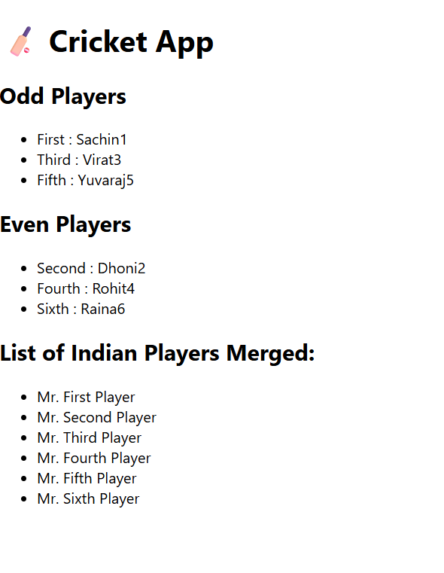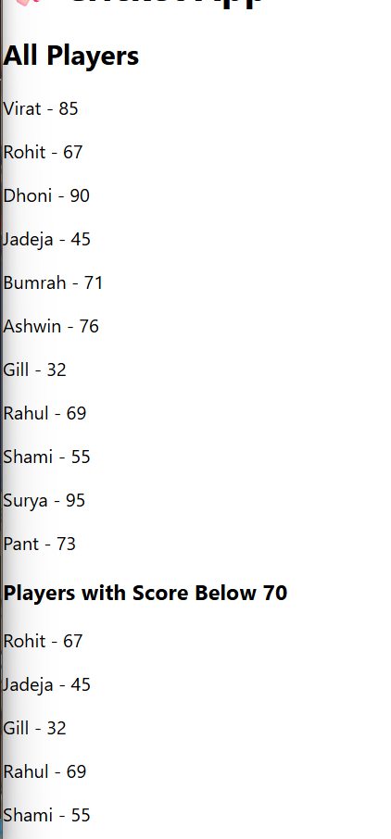

**Exercise – 10**

**// src/OfficeList.js**

import React from 'react';

const OfficeList = () => {

  const offices = [

    {

      name: 'WeWork Bangalore',

      rent: 75000,

      address: 'Koramangala, Bengaluru',

      image: 'https://via.placeholder.com/250x150?text=WeWork'

    },

    {

      name: 'Regus Mumbai',

      rent: 55000,

      address: 'Bandra, Mumbai',

      image: 'https://via.placeholder.com/250x150?text=Regus'

    },

    {

      name: '91Springboard Delhi',

      rent: 60000,

      address: 'Nehru Place, Delhi',

      image: 'https://via.placeholder.com/250x150?text=91Springboard'

    }

  ];

  const getRentStyle = (rent) => ({

    color: rent < 60000 ? 'red' : 'green',

    fontWeight: 'bold'

  });

  return (

    <div style={{ padding: '20px', fontFamily: 'Arial' }}>

      <h1>🏢 Office Space Rental Listings</h1>

      {offices.map((office, idx) => (

        <div key={idx} style={{ marginBottom: '20px', border: '1px solid #ccc', padding: '10px' }}>

          <img src={office.image} alt={office.name} style={{ width: '250px', height: '150px' }} />

          <h2>{office.name}</h2>

          <p><strong>Address:</strong> {office.address}</p>

          <p style={getRentStyle(office.rent)}><strong>Rent:</strong> ₹{office.rent}</p>

        </div>

      ))}

    </div>

  );

};

export default OfficeList;

**//src/App.js**

// src/App.js

import React from 'react';

import OfficeList from './OfficeList';

function App() {

  return (

    <div className="App">

      <OfficeList />

    </div>

  );

}

export default App;

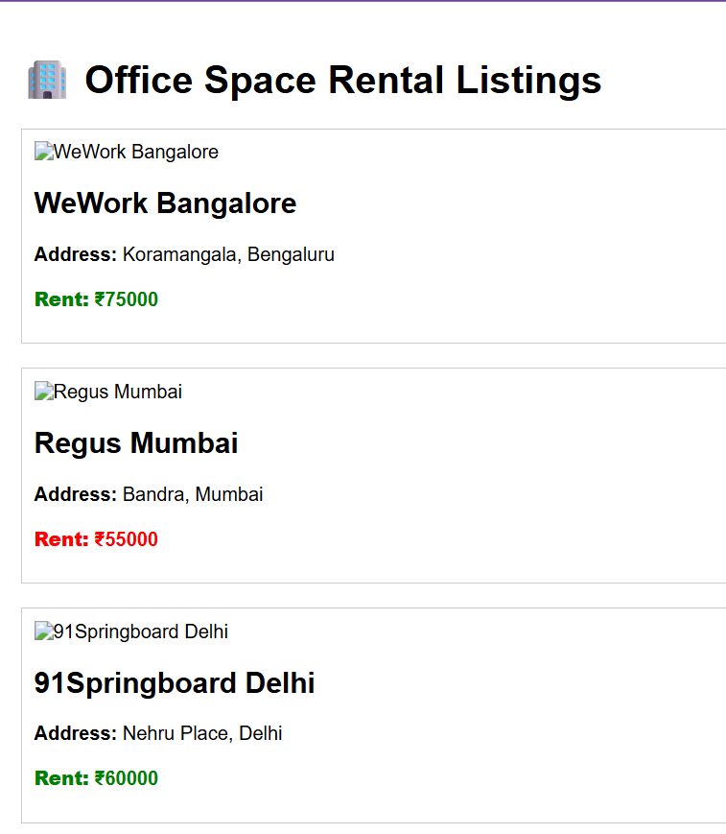

**Exercise -11**

**/src/components/CurrencyConvertor.js**

import React, { useState } from 'react';

const CurrencyConvertor = () => {

  const [rupees, setRupees] = useState('');

  const [euro, setEuro] = useState('');

  const handleSubmit = () => {

    if (!isNaN(rupees) && rupees !== '') {

      const converted = (parseFloat(rupees) / 88).toFixed(2); // 1 Euro = ₹88 approx.

      setEuro(converted);

    } else {

      setEuro('Invalid input');

    }

};

  return (

    <div>

      <h2>💱 Currency Convertor</h2>

      <input

        type="text"

        placeholder="Enter amount in ₹ Rupees"

        value={rupees}

        onChange={(e) => setRupees(e.target.value)}

      />

      <button onClick={handleSubmit} style={{ marginLeft: '10px' }}>Convert</button>

      <p>💶 Euro: {euro}</p>

    </div>

  );

};

**App.js**

import React, { Component } from 'react';

import CurrencyConvertor from './components/CurrencyConvertor';

class App extends Component {

  constructor(props) {

    super(props);

    this.state = {

      count: 0,

      message: ''

    };

  }

  increment = () => {

    this.setState({ count: this.state.count + 1 });

    this.sayHello(); // multiple methods on click

  };

  sayHello = () => {

    this.setState({ message: 'Hello! This is a static message.' });

  };

  decrement = () => {

    this.setState({ count: this.state.count - 1 });

  };

  sayWelcome = (msg) => {

    alert(`Welcome Message: ${msg}`);

  };

  handleSyntheticEvent = (event) => {

    alert('I was clicked (Synthetic Event)');

    console.log('Synthetic Event:', event);

  };

  render() {

    return (

      <div style={{ padding: '20px', fontFamily: 'Arial' }}>

        <h1>🖱️ React Event Handling Example</h1>

        <h2>Counter: {this.state.count}</h2>

        <button onClick={this.increment}>Increment</button>

        <button onClick={this.decrement} style={{ marginLeft: '10px' }}>Decrement</button>

        <p>{this.state.message}</p>

        <hr />

        <button onClick={() => this.sayWelcome("Welcome to React!")}>Say Welcome</button>

        <hr />

        <CurrencyConvertor />

      </div>

    );

  }

}

export default App;

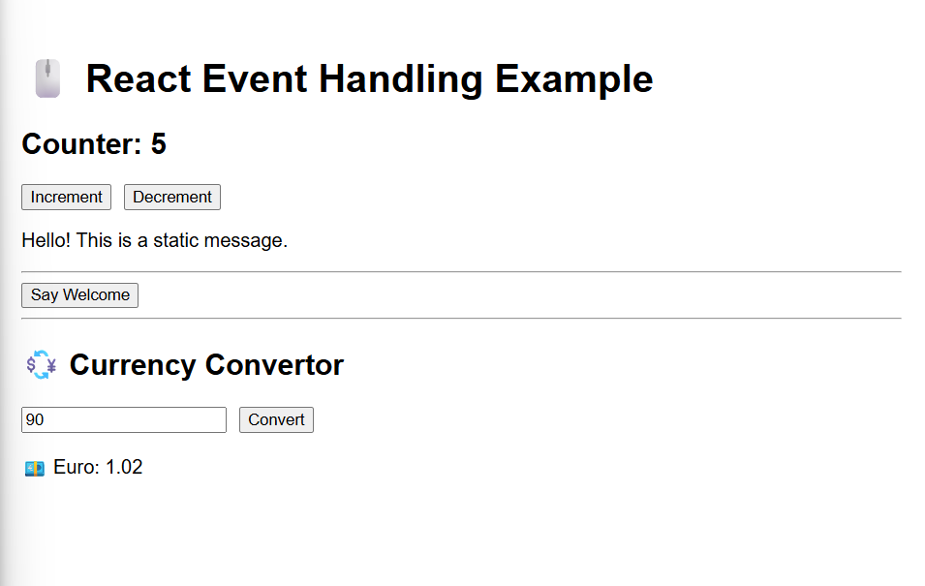

**Exercise – 12**

**//src/components/GuestPage.js**

// src/components/GuestPage.js

import React from 'react';

const GuestPage = () => {

  return (

    <div>

      <h2>Welcome, Guest!</h2>

      <p>Please login to book tickets.</p>

      <h3>Available Flights</h3>

      <ul>

        <li>✈️ Indigo - Delhi to Mumbai</li>

        <li>✈️ Air India - Bangalore to Goa</li>

        <li>✈️ SpiceJet - Kolkata to Chennai</li>

      </ul>

    </div>

  );

};

export default GuestPage;

**//src/components/UserPage.js**

// src/components/UserPage.js

import React from 'react';

const UserPage = () => {

  return (

    <div>

      <h2>Welcome, User!</h2>

      <p>You are logged in. You can now book tickets:</p>

      <ul>

        <li>🧾 Booked: Indigo - Delhi to Mumbai</li>

        <li>🧾 Booked: Air India - Bangalore to Goa</li>

      </ul>

    </div>

  );

};

export default UserPage;

**App.js**

// src/App.js

import React, { useState } from 'react';

function App() {

  const [isLoggedIn, setIsLoggedIn] = useState(false);

  const handleLogin = () => setIsLoggedIn(true);

  const handleLogout = () => setIsLoggedIn(false);

  let message;

  let button;

  if (isLoggedIn) {

    message = <h2>Welcome back</h2>;

    button = <button onClick={handleLogout}>Logout</button>;

  } else {

    message = <h2>Please sign up.</h2>;

    button = <button onClick={handleLogin}>Login</button>;

  }

  return (

    <div style={{ padding: '50px', fontFamily: 'Arial', textAlign: 'center' }}>

      {message}

      <br />

      {button}

    </div>

  );

}

export default App;

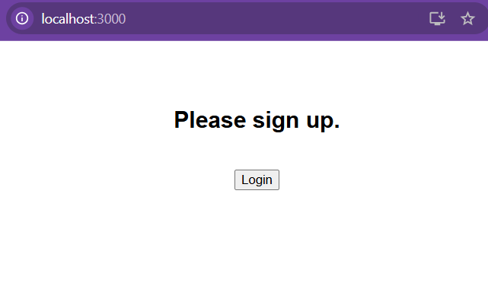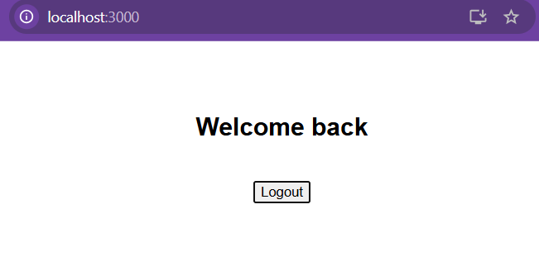

**Exercise – 13**

**//src/components/BlogDetails.js**

import React from 'react';

const BlogDetails = () => {

  const blogs = ['React Hooks Guide', 'Conditional Rendering in React', 'JSX Best Practices'];

  return (

    <div>

      <h2>Blog Details</h2>

      <ul>

        {blogs.map((blog, index) => (

          <li key={index}>📝 {blog}</li>

        ))}

      </ul>

    </div>

  );

};

export default BlogDetails;

**//src/components/BookDetails.js**

import React from 'react';

const BookDetails = () => {

  const books = ['Clean Code', 'You Don’t Know JS', 'Eloquent JavaScript'];

  return (

    <div>

      <h2>Book Details</h2>

      <ul>

        {books.map((book, index) => (

          <li key={index}>📖 {book}</li>

        ))}

      </ul>

    </div>

  );

};

export default BookDetails;

**//src/components/CourseDetails.js**

import React from 'react';

const CourseDetails = () => {

  const courses = ['ReactJS', 'Node.js', 'MongoDB'];

  return (

    <div>

      <h2>Course Details</h2>

      <ul>

        {courses.map((course, index) => (

          <li key={index}>🎓 {course}</li>

        ))}

      </ul>

    </div>

  );

};

export default CourseDetails;

**App.js**

// src/App.js

import React from 'react';

import  books from './books';

import './App.css';

function App() {

  const showBlogs = true;

  const showCourses = true;

  // Book section using map() and keys

  const bookdet = (

    <ul>

      {books.map(book => (

        <li key={book.id}>

          📘 {book.bname} - ₹{book.price}

        </li>

      ))}

    </ul>

  );

  // Blog section (conditional with if)

  const content = showBlogs ? (

    <ul>

      <li>📝 React vs Angular</li>

      <li>📝 Advanced State Management</li>

      <li>📝 Deploying React Apps</li>

    </ul>

  ) : null;

  // Course section (conditional with &&)

  const courseset = showCourses && (

    <ul>

      <li>🎓 ReactJS Complete Guide</li>

      <li>🎓 Node.js for Beginners</li>

      <li>🎓 Fullstack with MERN</li>

    </ul>

  );

  return (

    <div>

      <div className="st2">

        <h1>Book Details</h1>

        {bookdet}

      </div>

      <div className="v1">

        <h1>Blog Details</h1>

        {content}

      </div>

      <div className="mystyle1">

        <h1>Course Details</h1>

        {courseset}

      </div>

    </div>

  );

}

export default App;

